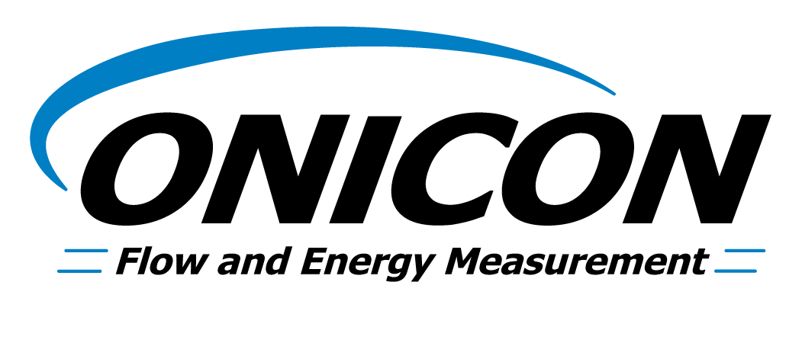
Energy (BTU) Measurement System Specification

For Central Energy Plant and Campus Applications

(Chilled Water, Heating Hot Water& Condenser Water) AUG 2013

Energy BTU Measurement System Specification

The entire Energy Measurement System shall be built and calibrated by a single manufacturer, ONICON Incorporated, and shall consist of a flow meter, two temperature sensors, a BTU meter, temperature thermowells, and all required mechanical installation hardware. A certificate of NIST* traceable calibration shall be provided with each system. All equipment shall be covered by the manufacturer’s two year warranty.

BTU Meter: Provide an ONICON System-10 BTU Meter. The BTU meter shall provide the following points both at the integral LCD and as outputs to the building control system: Energy Total, Energy Rate, Flow Rate, Supply Temperature and Return Temperature. Output signals shall be either serial network (protocol conforming to BACnet® MS/TP, BACnet/IP, LONWORKS®, JCI-N2, MODBUS RTU RS485, MODBUS RTU TCP/IP, or Siemens-P1) and/or via individual analog and pulse outputs. Each BTU meter shall be factory programmed for its specific application, and shall be re-programmable using the front panel keypad (no special interface device or computer required).

Temperature sensors: Temperature sensors shall be loop-powered current based (mA) sensors and shall be bath-calibrated and matched (NIST* traceable) for the specific temperature range for each application. The calculated differential temperature used in the energy calculation shall be accurate to within +0.15°F (including the error from individual temperature sensors, sensor matching, input offsets, and calculations).

Flow Meter: Refer to meter schedule for specific flow meter type. The flow meter shall be installed either in the supply or return pipe of the system to be measured following the manufacturer’s instructions with particular attention paid to upstream and downstream straight pipe runs. Insertion type flow meters shall be provided with all installation hardware necessary to enable insertion and removal of the meter without system shutdown and shall be hand insertable up to 400 psi. For installations in non-metallic pipe, install grounding rings or probes as required.

Note to Engineer: Turbine meters are not generally recommended for use in open loop condenser water applications. Use ONICON F-3200 Series Inline or F-3500 Insertion Electromagnetic flow meters instead.

Insertion Turbine Type:
Provide an ONICON Model F-1200 Dual Turbine Flow Meter. The flow meter shall have two contra-rotating axial turbines, with electronic impedance-based sensing and an averaging circuit to reduce measurement errors due to swirl and flow profile distortion. Each flow meter shall be individually wet-calibrated against a primary volumetric standard that is accurate to within 0.1% and traceable to NIST*. A certificate of calibration shall be provided with each flow meter. Accuracy shall be within ± 0.5% of rate at the calibrated velocity, within ± 1% of rate over a 10:1 turndown (3.0 to 30 ft/s) and within ± 2% of rate over a 50:1 turndown (from 0.4 to 20 ft/s). Output signal shall be a 0-15 V square wave pulse. Bi-directional meters shall be FB-1200 Series and shall include an isolated contact closure output for direction.

Insertion Electromagnetic Type:
Provide an ONICON Model F-3500 Insertion Electromagnetic Flow Meter. Materials of construction for wetted metal components shall be 316 SS. For installations in non-metallic pipe, install grounding rings or probes. The flow meter shall average velocity readings from two sets of diametrically opposed electrodes. Each flow meter shall be individually wet-calibrated against a primary volumetric standard that is accurate to within 0.1% and traceable to NIST*. A certificate of calibration shall be provided with each flow meter. Accuracy shall be within ± 1% of rate from 2-20 ft/s. Overall turndown shall exceed 100:1. Output signals shall be completely isolated and shall consist of the following: (1) high resolution frequency output for use with peripheral devices such as an ONICON display module or Btu meter, (1) analog output; 4-20mA, 0-10V, or 0-5V jumper selectable and (1) scalable dry contact output for totalization. Each flow meter shall be covered by the manufacturer’s two-year warranty.

Inline (full bore) Electromagnetic Type:
Provide an ONICON F-3200 Series Electromagnetic Flow Meter complete with integral or remote electronics module. The electronics module shall include a backlit graphic display and keypad. Connections to the piping shall be ANSI class 150 flanges (ANSI class 300 available where required). The installing contractor is responsible for providing suitable mating flanges. The flow tube shall be epoxy coated steel; the sensing electrodes shall be 316SS; the liner shall be polypropylene or ebonite for low temperature service, PFTE for hot water service. Each flow meter shall be individually wet-calibrated and accurate to within ±0.2% of reading from 1.6 to33 feet per second velocity. A certificate of calibration shall be provided with each flow meter. Output signals shall be 4-20 mA and programmable pulse. The flow meter shall be capable of measuring bi-directional flow. For installations in non-metallic pipe, install grounding rings between flanges. Each flow meter shall be factory programmed for its specific application, and shall be re-programmable using the integral keypad on the converter (no special interface device or computer required).

Clamp-on Ultrasonic Type:
Provide an ONICON Model F-4200 Clamp-on Transit Time Ultrasonic Flow Meter, complete with matched transducers, self-aligning installation hardware and coaxial transducer cables. The flow meter shall be installed without making any openings in the pipe wall and shall utilize non-wetted ultrasonic transducers that may be located up to 300 ft from the meter. Ultrasonic transducers provided must be optimized for the specific pipe & process conditions for each application and the transducer frequency shall be automatically matched to the resonant frequency of the pipe at start-up. An integral auto-zero function shall be provided for zero precision and high accuracy, even at very low flow velocities. The flow meter shall be capable of measuring bi-directional flow. Accuracy shall be within ± 1% of rate from 1 to 40 ft/sec and ± 0.01 ft/sec for velocities below 1 ft/sec. Overall turndown shall exceed 400:1.

* U.S. National Institute of Standards and Technology (or equivalent ISO standard)

